QIN ERIC2020-12-16 00:59
if you want to buy ,I may offer you special price
QIN ERIC2020-12-16 00:59
both ,I think
2020-12-16 00:58
Is the misunderstanding our fault?
QIN ERIC2020-12-16 00:57

2020-12-16 00:56
It is very expensive to buy another
QIN ERIC2020-12-16 00:55
You need to buy another time I think 
2020-12-16 00:52
That is unfortunate. Eric, what can we do?
2020-12-16 00:48
I see
QIN ERIC2020-12-16 00:48
yes
2020-12-16 00:47
Oh, I see. Maybe a misunderstanding?
QIN ERIC2020-12-16 00:47
I mean there may have conversation deviation
2020-12-16 00:46
I don't understand
2020-12-16 00:44
We gave special explanation
2020-12-16 00:44
But we asked for 0-5 V power control for previous. Described in requirements
QIN ERIC2020-12-16 00:44
unless special explanation ,otherwise default is no 5V control
2020-12-16 00:43
Why?
QIN ERIC2020-12-16 00:43
no ,previous don't have 5V control
2020-12-16 00:40
Is it on back?
2020-12-16 00:40
Ok, thank you. So we have 0-5 V power control on our unit?
QIN ERIC2020-12-16 00:38
Yes
QIN ERIC2020-12-16 00:38
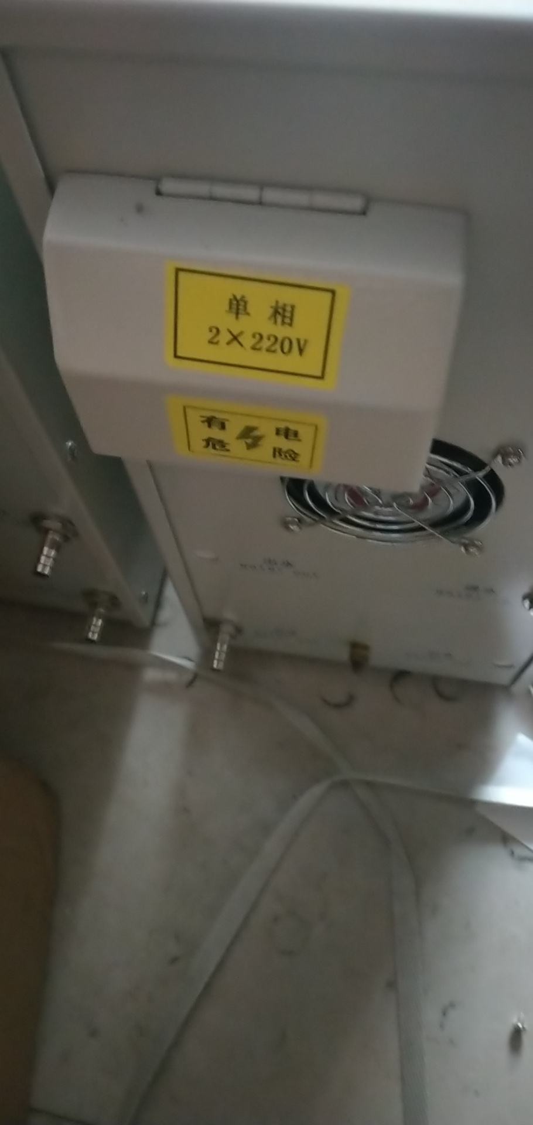
2020-12-16 00:37
I think we asked for 0-5 V power control
2020-12-16 00:36

QIN ERIC2020-12-16 00:35
that is 15KV
2020-12-16 00:28

2020-12-16 00:28

2020-12-16 00:28
I think I found some emails
QIN ERIC2020-12-16 00:27
indeed no 5V control
QIN ERIC2020-12-16 00:21
let me check again ,maybe some mistake ,they say it is 25KW
2020-12-16 00:20
Hmm, ok. But order was supposed to have 5V control, correct?
QIN ERIC2020-12-16 00:20
single phase ,sorry
QIN ERIC2020-12-16 00:19
it is 220V ,3 phase , but no 5V controll
QIN ERIC2020-12-16 00:19
we have confirmed
2020-12-16 00:19
Oh, I will be up for a while. I am a night owl 🦉. I will wait for the reply. Thank you for checking
QIN ERIC2020-12-16 00:17
we are still checking ,you can have a good night first ,and you can also add my whatsapp with +8618637176730 to get immediate contact .
2020-12-16 00:03
Thank you
QIN ERIC2020-12-16 00:02
let me check
2020-12-15 23:57
Does that make sense?
2020-12-15 23:56
This is true. I think in order it says 0-5 V power control. Where to look for this?
QIN ERIC2020-12-15 23:56
what is the problems now
QIN ERIC2020-12-15 23:55
it is 15Kw , confirmed
2020-12-15 23:54
I think it does not match SPZ-15. Did order maybe get switched with someone else's?
QIN ERIC2020-12-15 23:54
yes
2020-12-15 23:53
Is that right?
2020-12-15 23:51
It looks like this is picture of nameplate
2020-12-15 23:53
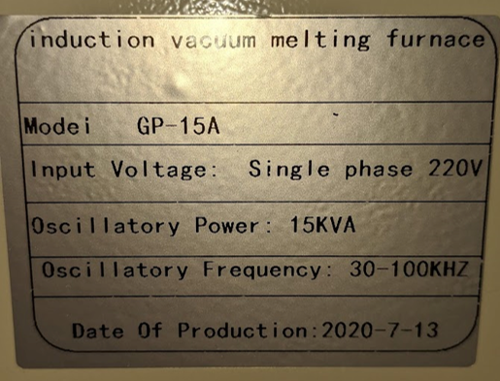
2020-12-15 23:50
I will try to send nameplate
2020-12-15 23:50
Unfortunately, I think SPZ-15 did not come
QIN ERIC2020-12-15 23:49
exactly
QIN ERIC2020-12-15 23:49
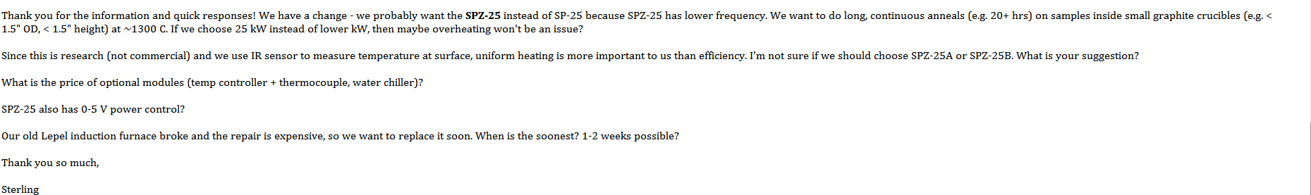
QIN ERIC2020-12-15 23:49
yes
2020-12-15 23:49
I think SPZ-15 is what we ordered
2020-12-15 23:49
Perfect!
QIN ERIC2020-12-15 23:48
I find your previous email
QIN ERIC2020-12-15 23:48

2020-12-15 23:45
Yes, I think the 2nd picture you sent is ours. Is that SPG-03A?
QIN ERIC2020-12-15 23:41
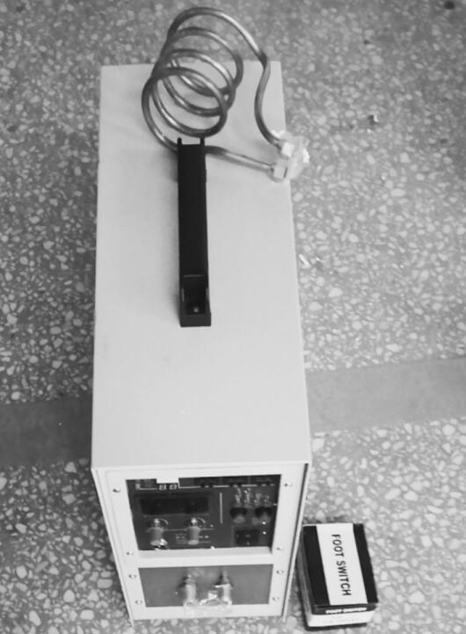
QIN ERIC2020-12-15 23:41
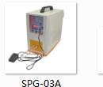
QIN ERIC2020-12-15 23:40
do you have requirement about the heating coil ?
QIN ERIC2020-12-15 23:40
Seems that your previous heating coil is customised
2020-12-15 23:40
Is that what it says on the order? Let me try to check
QIN ERIC2020-12-15 23:39
is it like this
QIN ERIC2020-12-15 23:39

2020-12-15 23:39
I think the date matches. We received the FEDEX confirmation number on 15/07/2020
2020-12-15 23:35
Does it show what items?
QIN ERIC2020-12-15 23:34
and as you said ,it is shirley I think
2020-12-15 23:34
Ok
QIN ERIC2020-12-15 23:34
So I believe it is our company for sure ,
QIN ERIC2020-12-15 23:34
this name Liming is just our company cooperate forwarder
QIN ERIC2020-12-15 23:33
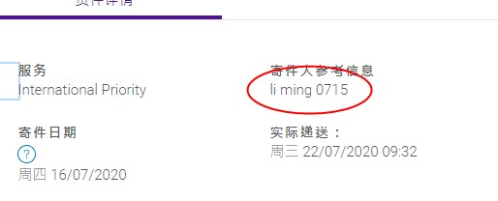
2020-12-15 23:32
I can send address
2020-12-15 23:32
Before that, did you find order?
Booking your shipment? Check out the shockingly simple experience at Alibaba.com Freight.
Compare rates
QIN ERIC2020-12-15 23:29
you can send me your delivery address and contact info ,so that I can make a proforma invoice for you . also with air express shipping cost ,right ?
2020-12-15 23:17
Thank you
QIN ERIC2020-12-15 23:16
OK ,understand
2020-12-15 23:16
My department tells me they sent emails to Shirley, but no response for a long time. Still no response.
QIN ERIC2020-12-15 23:15
I am still checking ,and the forwarder is indeed our forwarder
QIN ERIC2020-12-15 23:15
why
2020-12-15 23:15
I think it is Shirley. Unfortunately, I do not think we can work with her.
QIN ERIC2020-12-15 23:12
who you contact previously ?
QIN ERIC2020-12-15 23:11
yes
2020-12-15 23:11
I found the FEDEX tracking number: 770957055521. The information you sent matches the information I found:
BENEFICIARY:ZHENGZHOU CY SCIENTIFIC INSTRUMENT CO.,LTD
BANK: Bank of China,Henan Branch
ACCOUNT NO.: 2611 3773 8213
SWIFT CODE: BKCHCNBJ530
BANK ADDRESS:No. 87, ruida road, high-tech zone, Zhengzhou city , Henan province, China. (450000)
ZIP code: 450000
QIN ERIC2020-12-15 23:01
Account holder：ZHENGZHOU CY SCIENTIFIC INSTRUMENT CO.,LTD
Account number: 2611 3773 8213
Bank name:Bank of China,Henan Branch
Swift code: BKCHCNBJ530
Address:No. 87, ruida road, high-tech zone, Zhengzhou city , Henan province, China. (450000)
Bank Tel: 0371-67999985
Confirmed by: Eric
QIN ERIC2020-12-15 22:59
I will send you
2020-12-15 22:59
what is the wire transfer address for CYSI? I think I can find receipt
QIN ERIC2020-12-15 22:54
university
QIN ERIC2020-12-15 22:53
maybe ,at least we can't search the record of your colleague just now
2020-12-15 22:53
did you find the order?
2020-12-15 22:52
medium business man?
QIN ERIC2020-12-15 22:51
1800 USD with 110V voltage
QIN ERIC2020-12-15 22:50
but as it is 110V voltage ,the cost will add a little
QIN ERIC2020-12-15 22:50
you may buy it from medium business man I think
QIN ERIC2020-12-15 22:33
let me check again
2020-12-15 22:33
I do not know Catholic University of America. We are Brigham Young University. Is this same order?
QIN ERIC2020-12-15 22:32
but it is this university who bought from us this year
QIN ERIC2020-12-15 22:32
The Catholic University of America
QIN ERIC2020-12-15 22:32
Shirley , I think
2020-12-15 22:31
Who is that?
QIN ERIC2020-12-15 22:31
OK ,I let my colleague who take charge of your order previously contact you directly 
2020-12-15 22:30
Oh ok. Yes, I think that is the order
QIN ERIC2020-12-15 22:29
yes ,finished
2020-12-15 22:29
Hmm, payment was already made
QIN ERIC2020-12-15 22:29
is that your order ?
User recalled a message.
2020-12-15 22:25
We bought this year (2020)
QIN ERIC2020-12-15 22:25
which year you bought previously ?
2020-12-15 22:24
Ok
QIN ERIC2020-12-15 22:22
https://www.cysi.wang/Melting%20furnace/vacuum-induction-melting-furnace-15kw.html
QIN ERIC2020-12-15 22:22
It may takes time ,you can check this link first
2020-12-15 22:20
Yes
QIN ERIC2020-12-15 22:20
goods to United States
2020-12-15 22:19
Thank you Eric
QIN ERIC2020-12-15 22:19
let me check
2020-12-15 22:17
PG-15 or something?
2020-12-15 22:17
Oh ok. Can you look up my previous order? I am not sure which model it is
QIN ERIC2020-12-15 22:16
this price is EXW price 1600 USD
QIN ERIC2020-12-15 22:16
0-20Khz low frequency
QIN ERIC2020-12-15 22:15
induction heating coil+0-5V control +power supply
2020-12-15 22:15
Oh, you mean for water chiller?
2020-12-15 22:14
For induction heater?
QIN ERIC2020-12-15 22:13
1600 USD EXW price
2020-12-15 22:13
Oh, OK.
QIN ERIC2020-12-15 22:13
if there is no tilting function ,then you don't need cooling cable
2020-12-15 22:13
OK. No tilting function. Can you check which version of water chiller we got from CYSI?
QIN ERIC2020-12-15 22:12
you don't need tilting function when melting ,right ?
QIN ERIC2020-12-15 22:11
Possibly you will need water-cooled cable
2020-12-15 22:09
Can you double check something for me?
2020-12-15 22:08
We have a water chiller
2020-12-15 22:08
I don't understand
QIN ERIC2020-12-15 22:07
do you need cooling cable ?
2020-12-15 22:06
1-20 kHz
QIN ERIC2020-12-15 22:05
30-100Khz , usually we called it Medium frequency
QIN ERIC2020-12-15 22:05
what is your low frequency ?
2020-12-15 21:01
We want more uniform heating of graphite crucible. From what I read, low frequency gives more uniform heating. We try to carefully control temperature of sample inside graphite crucible. We want it close to melting point but not melting. Maybe medium frequency is OK. I will wait for after lunch time.
Always keep your communication and transactions on Alibaba.com website or app. Communication and transaction records will form the basis of dispute resolutions.
QIN ERIC2020-12-15 21:00
lunch time ,you can add my whatsapp with +8618637176730 to get response
QIN ERIC2020-12-15 20:56
usually we provide medium frequency and high frequency
QIN ERIC2020-12-15 20:56
but why you need low frequency ?
2020-12-15 20:56
Correct
QIN ERIC2020-12-15 20:56
Low frequency, 15 kW, and 0-5 V voltage power control
2020-12-15 20:56
Yes, I think so.
QIN ERIC2020-12-15 20:55
you mean power supply and the heater
2020-12-15 20:52
Oh, I see. We already have quartz tube, temperature controller, pyrometer, turbo pump, etc. We just need heater unit with voltage control.
QIN ERIC2020-12-15 20:51
https://www.cysi.wang/Melting%20furnace/Small-vacuum-induction-furnace.html
QIN ERIC2020-12-15 20:50
https://www.cysi.wang/Melting%20furnace/25kw-lab-small-temperature-controlled-induction-melting-furnace.html
2020-12-15 20:48
Yes, turbo pump
QIN ERIC2020-12-15 20:48
I send you link to check
QIN ERIC2020-12-15 20:48
you mean vacuum pump
2020-12-15 20:48
Thank you for checking
2020-12-15 20:47
Oh, we have our own vacuum. We just need heater
QIN ERIC2020-12-15 20:47
as sometimes high temperature need vacuum condition
2020-12-15 20:47
I do not know. Where can I check?
QIN ERIC2020-12-15 20:46
what is your previous induction furnace temperature ?
2020-12-15 20:45
Small amount, only ~20-40 g of graphite, but high temperature (1500 +/- 20 C). We need to run for long time (continuous 3-7 days)
QIN ERIC2020-12-15 20:41
what materials
QIN ERIC2020-12-15 20:41
how many kilograms
QIN ERIC2020-12-15 20:41
and the capacity of loading ?
2020-12-15 20:40
Thank you
QIN ERIC2020-12-15 20:40
yes
2020-12-15 20:34
Are you still there?
2020-12-15 20:28
Do you have one like that?
2020-12-15 20:27
Low frequency, 15 kW, and 0-5 V voltage power control
QIN ERIC2020-12-15 20:26
yes , you have any requirement ?
2020-12-15 20:25
We previously bought an induction heater from your company. It seems to be a nice product. I was hoping to get info on your induction heaters. Do you have induction heaters with voltage power control?
QIN ERIC2020-12-15 20:23
you need indcution furnace or vacuum induction ?
QIN ERIC2020-12-15 20:23
fine
2020-12-15 20:23
Hi, I'm doing well. How are you?
QIN ERIC2020-12-15 20:23
hi,dear bro ,how are you
2020-12-15 20:21
Hi Eric
QIN ERIC will serve you on the following inquiries.
InquiryID: 101131123251

Product inquiry from Sterling Baird .
View Chat Details
To protect your orders，always communicate and pay

